Base 1 – Reception (single year group)
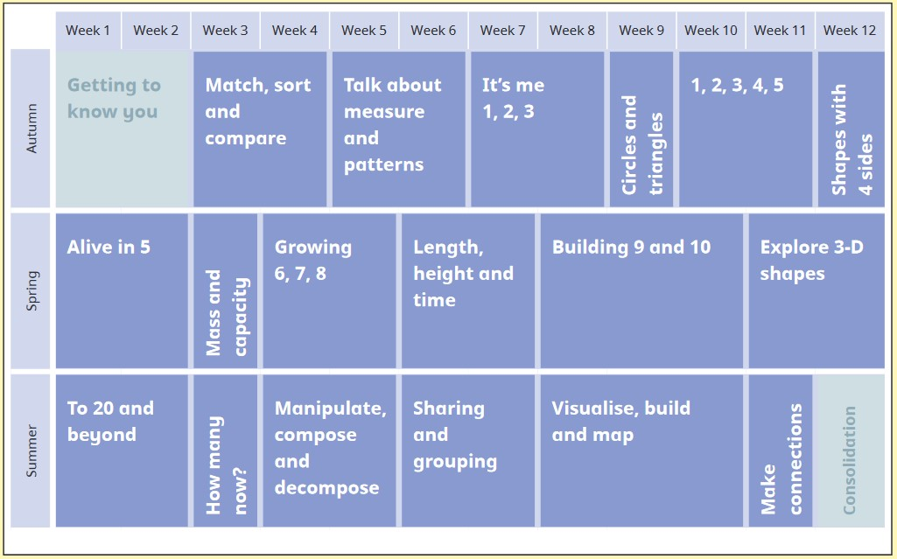
As in Y1, Shape, Space & Measure activities are delivered on a Friday and taught in sequence through the year.
YR get differentiated, small-group guided maths every day. There is also a maths activity in continuous provision and open access to the maths trolley every day.
End of unit assessments are from Twinkl (which works in conjunction with White Rose).
Base 1 - Year 1 – single year group scheme
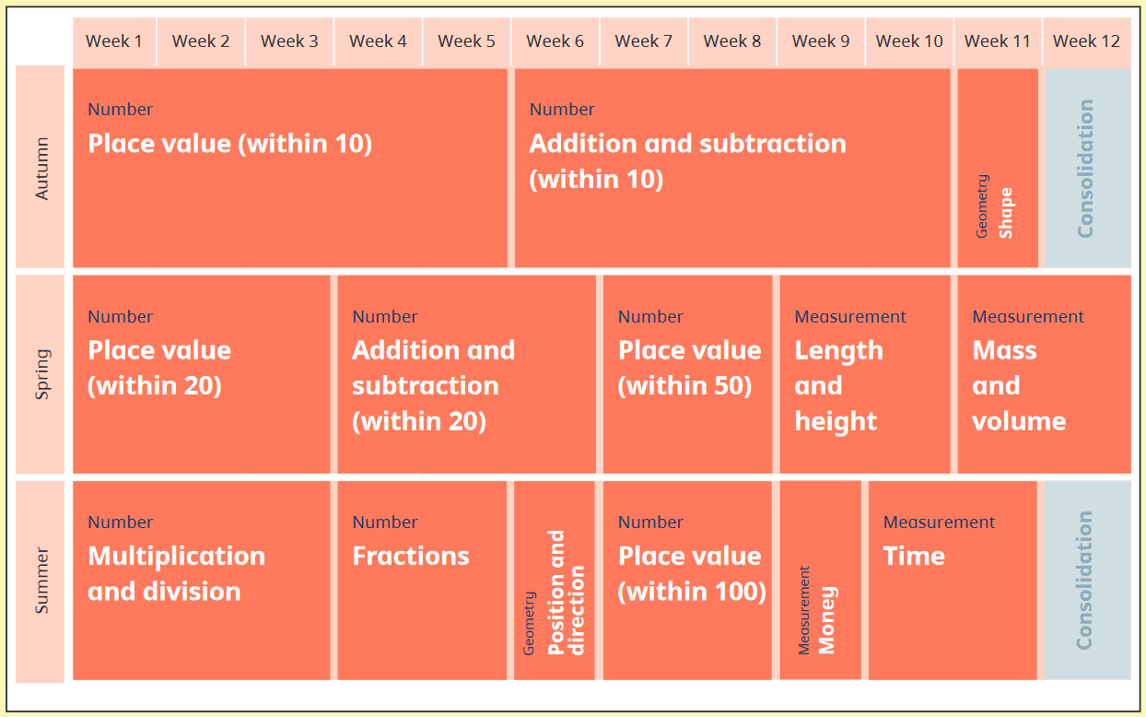
‘Number’ units taught in sequence as shown, Monday-Thursday.
‘Geometry’ and ‘Measure’ units taught on Fridays, in sequence, though year.
Base 2 – Year 2– single year group scheme
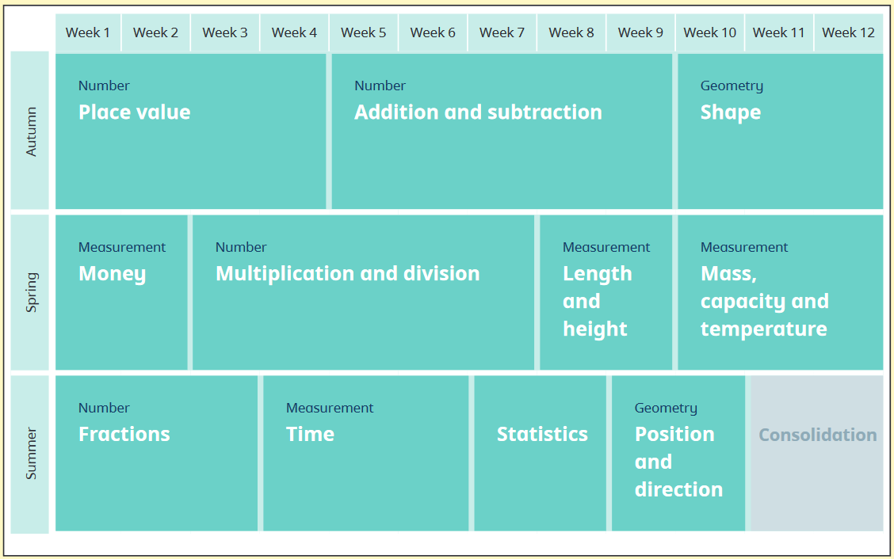
Base 2 – Year 3 – single year group scheme
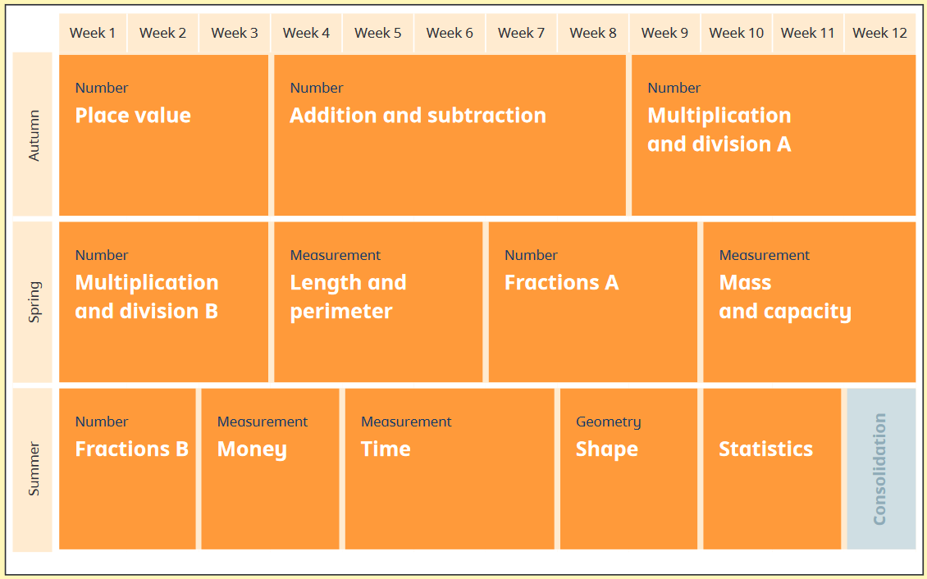
2024 Spring – Y2 & 3 Mass & Capacity units taught throughout term on Fri afternoons
Base 3 - Year 4 & 5 – mixed age planning
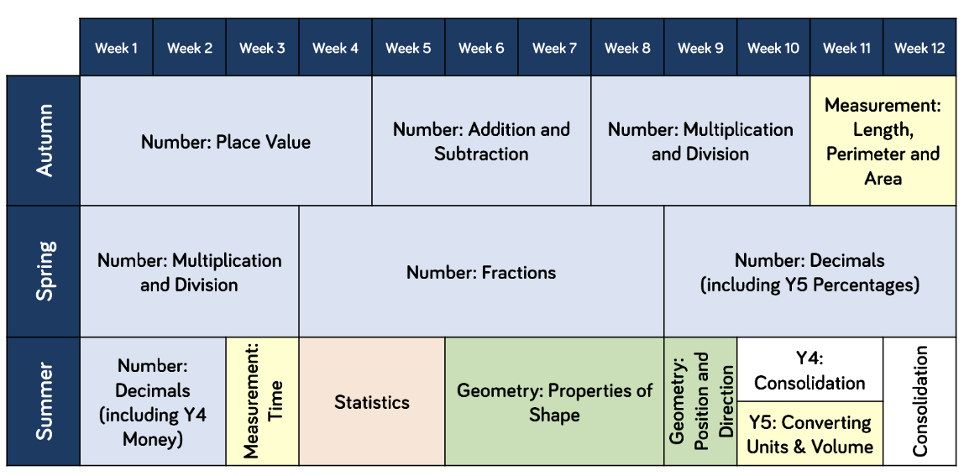
Two units marked with start usually swapped because it’s a more efficient use of long Autumn Term.

Base 3 - Year 6 – single year group scheme


